Titel: | Light My Fire |  | Interpret: | The Doors |  | Tempo: | 125bpm

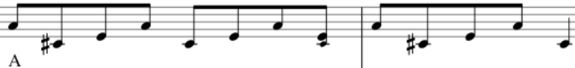
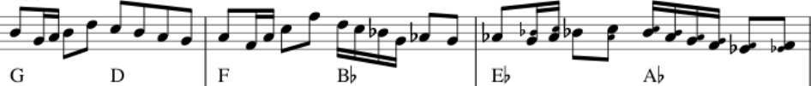

1 Schlag Drums => [Intro – Organ & All] G D F B_{b} E_{b} A_{b} A A

Am F#m Am F#m
You know that it would be untrue You know that I would be a liar

Am F#m Am F#m
If I was to say to you Girl, we couldn't get much higher

G A D/D_{sus4}/D G A D B G D E E₇
Come on baby, light my fire - Come on baby, light my fire - Try to set the night on fire

Am F#m Am F#m
The time to hesitate is through No time to wallow in the mire

Am F#m Am F#m
Try now we can only lose And-our love become a funeral pyre

G A D/Dsus4/D G A D B G D E E7
_{Come on baby, light my fire} - Come on baby, light my fire - Try to set the night on fiiire - yeeah
[Elendig langes Ogan-Solo] Am Bm Am Bm …..
[Elendig langes Guitar-Solo] Am Bm Am Bm …..

[Wie Intro – Organ & All] G D F B_{b} Eb Ab A A

Am F#m Am F#m
The time to hesitate is through No time to wallow in the mire

Am F#m Am F#m
Try now we can only lose And-our love become a funeral pyre

G A D/D_{sus4}/D G A D B G D E E₇
Come on baby, light my fire - Come on baby, light my fire - Try to set the night on fiiire - yeah

Am F#m Am F#m
You know that it would be untrue You know that I would be a liar

Am F#m Am F#m
If I was to say to you Girl, we couldn't get much higher

G A D/D_{sus4}/D G A D B F C D
Come on baby, light my fire - Come on baby, light my fire - Try to set the night on fire F C D F C D F C D D
Try to set the night on fire Try to set the night on fire Try to set the night on fi---re !

[Outro – Organ & All] G D F B_{b} Eb Ab A A

